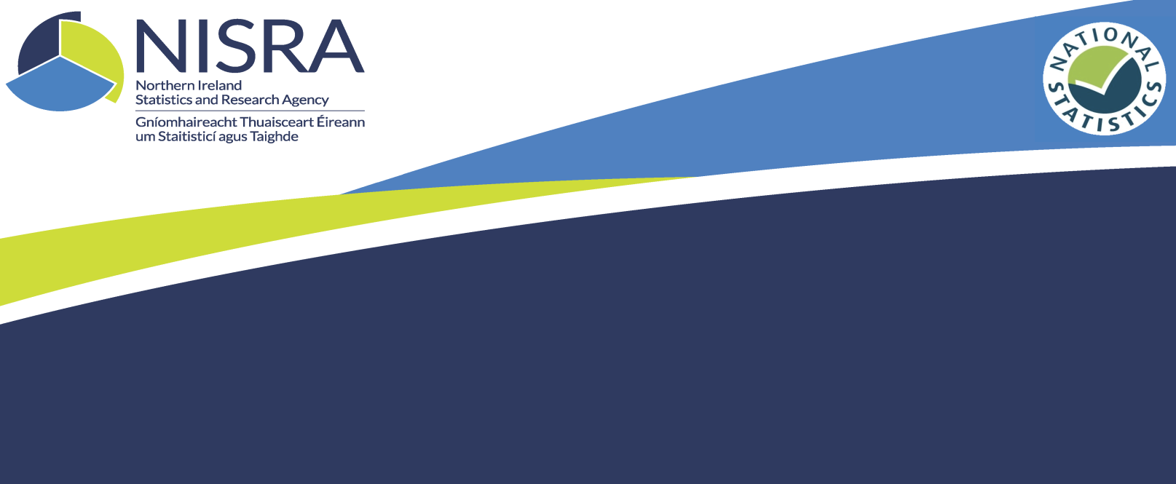
Women in Northern Ireland
Consultation Outcome
We Asked
We asked for your feedback on your use of the Women in Northern Ireland annual publication. We wanted to assess if the publication should continue to be produced and if it should remain in the same format. The consultation ran from 7th December 2017 to 25th January 2018.

You Said
Known users of the Women in Northern Ireland publication were invited directly to take part in the consultation and in addition a wider invitation was issued via twitter. In total, there were 4 responses to the consultation; 3 via citizen space and 1 via postal feedback template. We would like to thank all respondents for taking the time to respond to the consultation.
The main feedback included:
- Two respondents stated they were first-time users of the publication, one stated they regularly (at least once a month) use the publication and another stated they occasionally (less than once a month but more than once a year) use the publication.
- The responses welcomed the publication’s coverage of different statistics, the commentary alongside the figures and the engaging infographic.
- Users were asked about the specific topic areas they made use of, the responses were as follows:

We Did
We reviewed the feedback provided by respondents. The low response rate to the Women in Northern Ireland consultation indicates the current publication is not being widely accessed by users. Taking the feedback into account we are going to undertake the actions listed below:
- Base future Women in Northern Ireland publications on Labour Force Survey data only and include a greater analysis of that data. A list of links to the additional sources will be included in the revised publication for information. Annex 1 provides a list of links to the sources of the data that will be removed from the publication. These links will be updated and included in the revised publication for information.
- The focus of the publication will be widened to cover families and the labour market, and analysis across both genders will be included.
- As a result of ongoing development of our annual and quarterly publications, this publication will remain under review and users will be informed of any planned changes.

Annex 1

3.2 Childcare provision Day care places (source: Department of Health)
https://www.health-ni.gov.uk/topics/dhssps-statistics-and-research/childrens-services-statistics link to Children’s services statistics
https://www.health-ni.gov.uk/sites/default/files/publications/health/child-social-care-16-17.pdf link to publication

3.3 Assistance for parents Benefit Claimants (Source: Department for Communities)
https://www.communities-ni.gov.uk/topics/benefits-statistics link to benefits statistics summary publication
https://www.communities-ni.gov.uk/publications/benefits-statistics-summary-publication-national-statistics-november-2017 link to publication

Child and working tax credits (source: Her Majesty’s Revenue and Customs)
https://www.gov.uk/government/collections/personal-tax-credits-statistics link to personal tax credit statistics
https://assets.publishing.service.gov.uk/government/uploads/system/uploads/attachment_data/file/617128/Child_and_Working_Tax_Credits_statistics_finalised_annual_awards_-_2015_to_2016.pdf link to publication

4 Educational standards (Source: Department of Education)
https://www.education-ni.gov.uk/publications/school-leavers-201516-statistical-bulletin link to school leavers statistics
https://www.education-ni.gov.uk/sites/default/files/publications/education/Qualifications%20and%20Destinations%20of%20Northern%20Ireland%20School%20Leavers%20201516.pdf link to publication
Higher and Further Education (source: Department for the Economy)
https://www.economy-ni.gov.uk/publications/further-education-activity-northern-ireland-201617
https://www.economy-ni.gov.uk/sites/default/files/publications/economy/FE-Activity-Statistical-Bulletin-1314-to-1617_0.pdf
https://www.hesa.ac.uk/data-and-analysis/students/what-study
Subject Choices at NI Further Education Colleges (source: Department for the Economy)
https://www.economy-ni.gov.uk/sites/default/files/publications/economy/FE-Activity-Statistical-Bulletin-1314-to-1617_0.pdf link to publication

5 Women in politics and public life
https://www.executiveoffice-ni.gov.uk/articles/public-appointments
www.parliament.uk
www.europarl.europa.eu

6 Women into business
https://www.enterpriseresearch.ac.uk/wp-content/uploads/2017/11/GEM-NI-2016-Final-report.pdf link to publication

