Online Occupancy Survey Guidance

Contents
- How to Complete the Online Survey
(This section shows how the online survey works including images to aid the respondent. It also includes details on messages that may appear which may cause confusion while completing)
- Question Guidance
(This section includes more details on the questions you will be asked to answer and what to include or exclude (e.g. children in cots/Guests/Arrivals)
- Questions and Answers
(This section includes some common questions and answers a respondent may have about the Occupancy Survey)

Version 1
Last updated 25/1/23
How to Complete the Online Survey
- Preparation
- Starting the Survey
- Access code
- Moving around the Questionnaire
- “Answer field required”
- “Additional question guidance”
- “OK Signal button”
- “Total not available”
- Country of origin breakdowns (Guests and Arrivals)
- “Submit”

Return to Contents Page

Preparation
NISRA Tourism Statistics will email you monthly with a survey link and your individual access code. To complete the survey, you should have your Occupancy figures for the month (e.g. January) ready to input. We are interested in totals for the month not daily figures, so this keeps the survey quite short to fill in.
You may wish to keep your own daily record and total these figures for the month.

Starting the survey
Click on the survey link provided in your survey invite email and press START

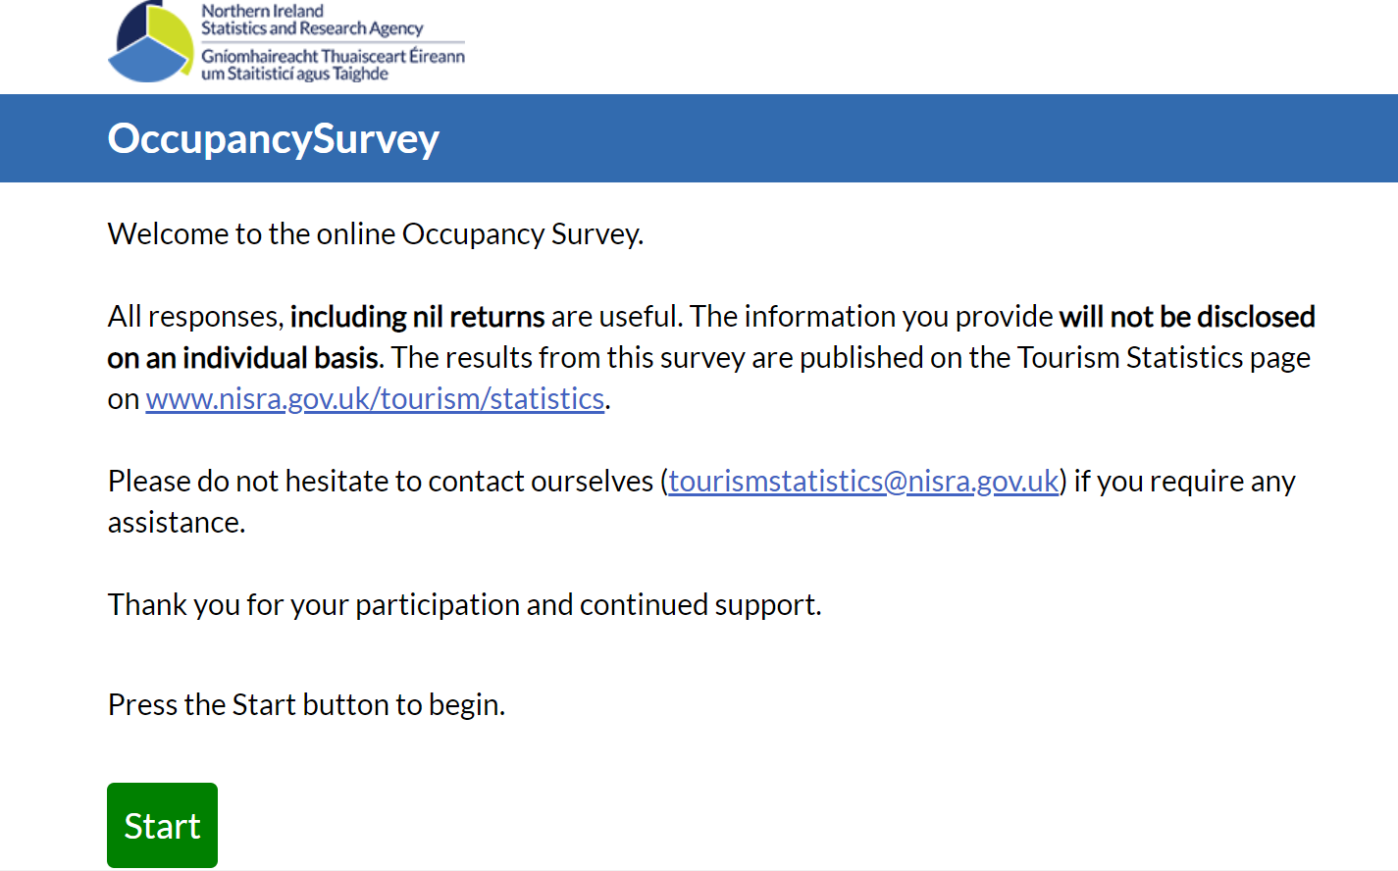

Return to Contents Page
Return to “How to Complete the Online Survey”

Access code
Enter your 16 digit access code provided in your survey invite email. The first 3 letters represent the month you are providing figures for e.g. JAN stands for January.

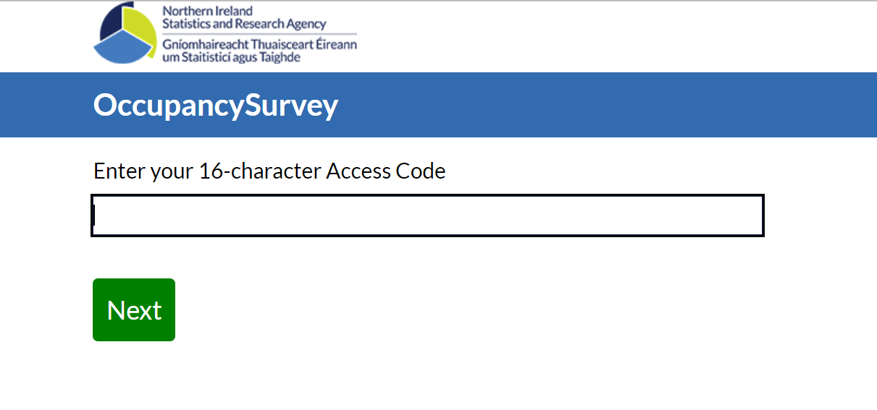
Press NEXT
Please note if the survey has already been completed by another member of your team it will say ‘The unique access code entered does not exist’ as it has already been entered.
Once you are into the survey you can start to answer the questions. Please refer to the question guidance below when completing the survey.
Return to Contents Page
Return to “How to Complete the Online Survey”

Moving around the questionnaire
You can move forward and backward through the questionnaire by using the NEXT and PREVIOUS options.

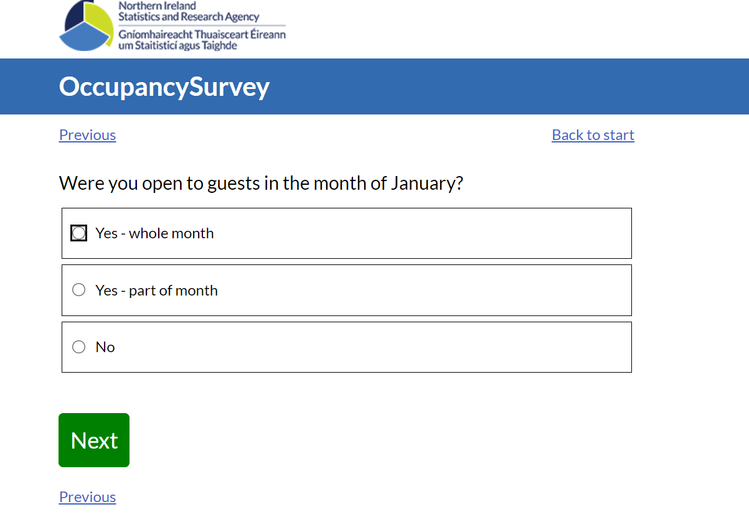

Return to Contents Page
Return to “How to Complete the Online Survey”

Answer field required
If you have left a question unanswered, the survey will notify you that an answer is required. Please enter the answer and you will be able to move on through the survey.

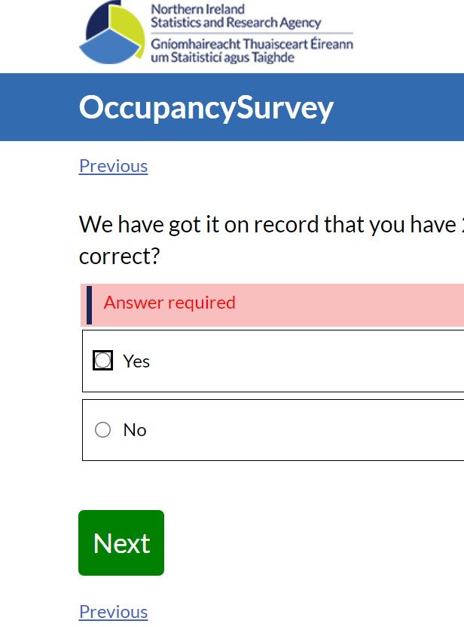

Return to Contents Page
Return to “How to Complete the Online Survey”

Additional question guidance
Some questions provide additional guidance below certain questions. Please use this to help you fill in the data.
For example:
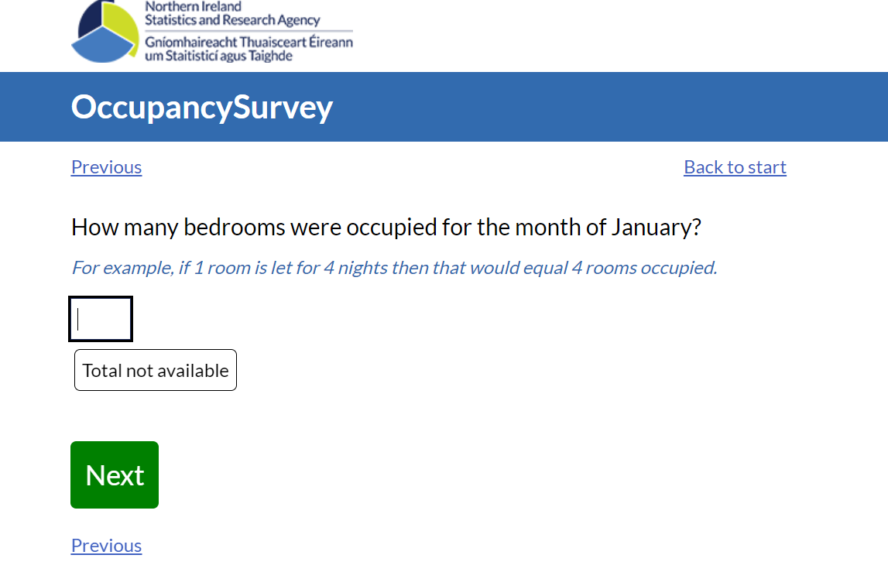
Return to Contents Page
Return to “How to Complete the Online Survey”

OK signal button
Checks throughout the survey may appear asking you to check what you have entered.
If an OK signal appears it is asking you to check what you have entered. Click OK then alter the information you put in if need be or if it was the correct then you can keep it in. Then click NEXT.

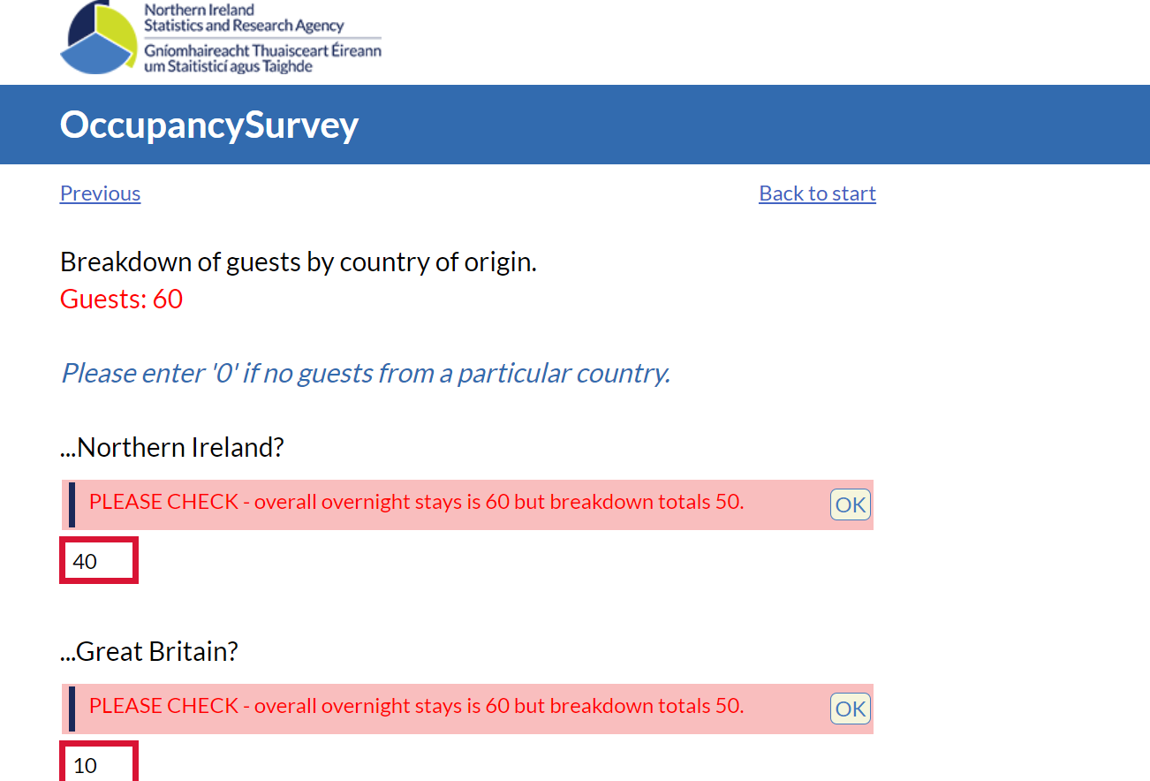

However, for some questions the answers need to make sense and if they don’t you will not be able to move through the survey. For these please check your figures and amend.
Examples include:
You cannot have more arrivals than guests.
You cannot have more guests than bedspaces.
Country of residency guest breakdowns should add up to the total guests.
Country of residency arrivals breakdowns should add up to the total arrivals.

Return to Contents Page
Return to “How to Complete the Online Survey”

Total not available button
Some questions have a total not available button. If you do not have figures for these questions and this button is available please click the TOTAL NOT AVAILABLE button and then click NEXT.

Return to Contents Page
Return to “How to Complete the Online Survey”

Country of origin breakdowns for guests and arrivals
Country of origin is the country in which the guest/arrival has their permanent address and not their nationality. Breakdowns provided are Northern Ireland, Great Britain, Republic of Ireland, Europe, USA & Canada, The Rest of the World.
The guest country of origin breakdowns should add up to the total guests.
The arrivals country of origin breakdowns should add up to the total arrivals.
All categories need a value so if there were none for a particular category, please enter a zero.
Return to Contents Page
Return to “How to Complete the Online Survey”

Submit button
To submit your survey to us click the SUBMIT button at the end of the survey.
You can enter and exit the survey as often as you wish as long as you don’t click the submit button at the end. Once the submit button is clicked you will no longer be able to enter the survey for that month and the information has been submitted to us.
Please note if you keep the questionnaire open for a lengthy period it will time out.
If you forget to click on the SUBMIT button, the survey will appear as “incomplete” on the system and you will receive reminder emails about this.

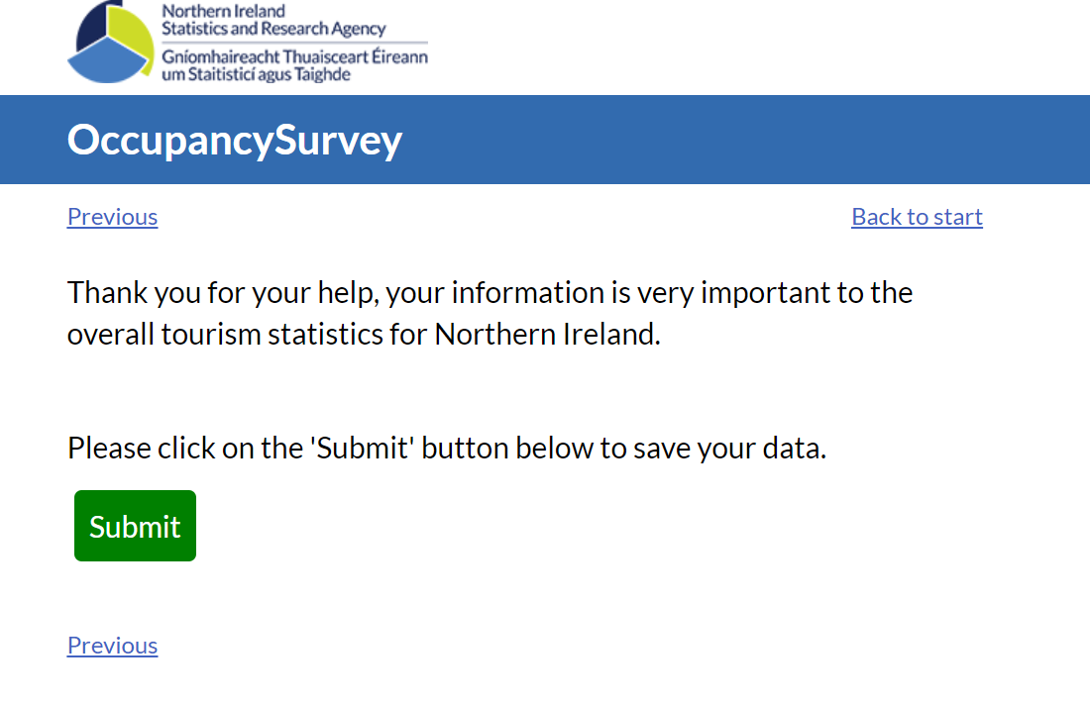
Return to Contents Page
Return to “How to Complete the Online Survey”

Question Guidance
How many bedrooms do you have available? (Regardless of whether there are any guests staying in them)

This is the total bedrooms you have regardless of whether there are any guests staying in them. Please note if you have closed some rooms e.g. for renovation then please don’t count these rooms.

How many bedspaces do you have available? (Regardless of whether there are any guests staying in them)

This is the total bedspaces you have regardless of whether there are any guests staying in them. Bedspaces available refers to the maximum number of guests which can be accommodated, rather than the number of beds, i.e. a double bed should be counted as two bedspaces. You should not include children's cots. Please note if you have closed some rooms/bedspaces e.g. for renovation then please don’t count these bedspaces.

How many bedrooms were occupied for the month?

This is the number of bedrooms occupied each day totalled for the month.
For example:
Let’s say you were only open for 3 days in the month, let’s say the 1st - 3rd of the month and you let out the following number of bedrooms –
On 1st day of the month 6 rooms were let out
On 2nd day of the month 2 rooms were let out
On 3rd day of the month 4 rooms were let out
This means the answer to the above question ‘How many bedrooms were occupied for the month?’ would be 12 i.e. 6+2+4=12

If you were open all month then each day’s values for the full month need totalled.

In total, how many overnight guests did you have for the month?

For example, 2 people arriving and staying 3 nights would equal 6 guests.

Total overnight guests refers to all guests staying, i.e. both those arriving on a day and those who had booked in on a previous day and still remain as staying guests. Please provide figures for the month.

Children in cots should not be included for the purposes of this survey. If a child is occupying a bed, which could otherwise be used by an adult, the child should count as one guest. Please do not refer to 1/2 guests.

Breakdown of guests by country of origin

Country of origin is the country in which the guest has their permanent address and not their nationality. Breakdowns provided are Northern Ireland, Great Britain, Republic of Ireland, Europe, USA & Canada, The Rest of the World. The total figures added from these breakdowns should match the total number of guests you provided in the previous total overnight guests question.

In total, how many arrivals did you have for the month?

For example, a couple arriving and staying for 4 nights would equal 2 arrivals.
Total arrivals refer to only those people who have arrived and booked in on a day in question. Please provide figures for the month.

Children in cots should not be included for the purposes of this survey. If a child is occupying a bed, which could otherwise be used by an adult, the child should count as one guest. Please do not refer to 1/2 guests.

Breakdown of arrivals by country of origin
Country of origin is the country in which the guest has their permanent address and not their nationality. Breakdowns provided are Northern Ireland, Great Britain, Republic of Ireland, Europe, USA & Canada, The Rest of the World. The total figures added from these breakdowns should match the total number of arrivals you provided in the previous total arrivals question.

The survey has checks in place to ensure the data makes sense. For example, if you entered that you had more arrivals than guests, the survey will notify you, asking you to check if the figures are entered correctly. You can amend your figures at this stage. You could never have more arrivals than guests, nor could you have more guests than bedspaces available.

Return to Contents Page
Online Occupancy Survey - Questions and Answers (Q&As)

Why/How has my establishment been selected?
To offer tourist accommodation in Northern Ireland, you must have a certificate from Tourism Northern Ireland (TNI) - TNI refers to this as certification. It is illegal to offer tourist accommodation in NI without a certificate from TNI. The list of certified accommodation from TNI is known as the ‘stock’. At the beginning of the year, all hotels and a random sample of Guest Houses, B&Bs, and Guest Accommodation in Northern Ireland is drawn from the stock. Those selected are invited to participate in the survey.

Is the survey compulsory?
The survey is not compulsory, but your input is much appreciated. The information from the survey helps to inform us on the performance of the tourism sector and aids policy makers in their decisions.

Is the information I give confidential?
The information you provide will not be disclosed on an individual basis. The results from this survey are published on the Tourism Statistics page on www.nisra.gov.uk/statistics/tourism.

Why is the survey moving online?
From 2023 the survey moves online. This reduces the environmental impact by going paperless and also reduces the burden on respondents, making the survey more user friendly. We have simplified the survey to request information for totals only and this allows us to analyse and present the information in a way which helps us understand the sector.

Why are my details on number of rooms/bedspaces different on the survey?
The details we have for you come from the information TourismNI hold for you on their stock list. Each month you may have certain rooms closed for renovation or for other reasons. Please just enter the correct details for the month in question, pertaining to your circumstances and calculations will be based on these.
Return to Contents Page

