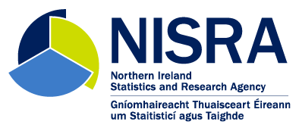

**Labour Market Statistics User Group 2021 Feedback**

December 2021

**Introduction**

The 2021 Labour Market Statistics User Group took place on 30th September and, for the second year running, was held online. The User Group was advertised on the NISRA website, within labour market statistics publications, to the labour market statistics customer list, and on social media. Almost 60 people attended the User Group meeting.

Following the meeting, the presentations and a record of questions and answers were made available to users on the [Labour Market Statistics User Engagement](https://www.nisra.gov.uk/statistics/labour-market-and-social-welfare/labour-market-statistics-user-engagement) section of the [NISRA website](https://www.nisra.gov.uk/).

Attendees were invited to fill out an online feedback questionnaire covering the format of the user group, the content and frequency, what impact it had on their understanding or usage of the statistics and if they had any suggestions for improvement. Approximately a fifth of attendees completed the feedback survey.

The following report summarises the responses received.

**Summary Analysis of Feedback**

* Overall the feedback was very positive with all respondents saying they were either satisfied or very satisfied (over 90% said very satisfied).
* Attendees found the presentations interesting and informative; and appreciated the interactivity of the session. Specific content that attendees found useful included the latest position of the surveys and plans for the way forward, explanations of the key differences between sources, explanations behind why different breakdowns are not available and the impact of COVID-19 on data collection and outputs.
* All respondents agreed that there was nothing missing from the content of the User Group.
* Almost all attendees felt that the length of the User Group was ‘about right’ with only one respondent saying that it was ‘too short’.
* One attendee would like User Groups to take place more often than annually with the remainder saying that annual is about right.
* All participants felt that the breadth of the content for the User Group was ‘about right’ and that it helped with their understanding of labour market statistics.
* The majority of respondents did not feel that the Labour Market User Group meeting would change how they will use labour market statistics in the future, although the main reason given for this was that they are already experienced users of these statistics. However, some said that the meeting had given them further context and a greater awareness of the range of surveys and statistics available.
* One suggestion for an improvement to future Labour Market Statistics User Group meetings was to return to face-to-face meetings when possible.

**Next Steps**

Based on the feedback

* A Labour Market Statistics User Group meeting will again be organised for autumn 2022. Input on the content of the meeting will be sought from stakeholders during the registration process in a similar manner to the 2021 event.
* We will consider how best to mix face-to-face and online formats for the 2022 User Group meeting.