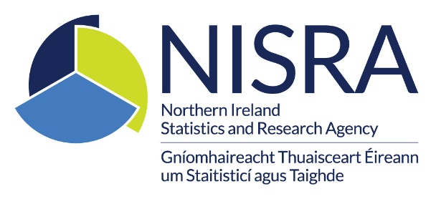

**Review of the Annual Sickness Absence in the Northern Ireland Civil Service Report**

**Background**

The financial challenge facing public services in Northern Ireland has been well publicised. Resource expenditure across the NICS is falling at a time of rising cost pressure, putting departmental budgets under pressure. NISRA has been developing strategies to meet this shortfall including tailoring our outputs and activities to align with available resources while continuing to produce high quality statistics.

As part of the wider effort to operate within these financial constraints, the Workforce Statistics & Analysis (WSA, formerly NISRA Human Resource Consultancy Services) team reviewed the content and format of a number of publications in 2023. This included the annual [Sickness Absence in the NICS](https://www.nisra.gov.uk/publications/sickness-absence-northern-ireland-civil-service-202223-updated-available-other) report. There are three main elements to this report – a set of excel tables, and a written report which contains the same tables and descriptive commentary as well as an Infographic.

A formal consultation with users opened on Monday 18 September 2023 and closed on Thursday 8 November 2023, including a three-week extension at the request of customers. Notice of the consultation was placed on Departmental Intranets, the NISRA website, Twitter and Facebook feeds. In addition, an email was sent to those on the Sickness Absence in the NICS user mailing list. Users were invited to complete our online [questionnaire](https://consultations2.nidirect.gov.uk/dof/review-of-sickness-absence-statistics-in-the-nics/) to provide feedback on :

* their usage of the report and particular sections within it, including reasons for use, the element used (written report, tables and infographic) and frequency of use;
* how the report meets their needs; and
* the impact of proposed changes to the report – specifically proposals to suspend or scale back the written report and Excel tables.

**Summary of Responses**

**Users**

We received 21 responses to the consultation, all which were from internal NICS users.

The main reasons for use were identified as:

* Policy making/monitoring (11)
* To aid decision making on resource allocation (9)
* Responding to information requests (8)
* To facilitate research (6)

**Elements Used**

All 21 users responded that they used the written report, and 12 used the Excel tables. Each section of the report was used often or occasionally by all users. Only 1 respondent did not use the Excel tables or Infographic

**Meeting Needs**

When asked to what extent the current annual Sickness Absence in the NICS report met their needs, seven said fully, 10 said mostly and four said partly. When asked about each section of the output, most users (at least 16) reported the corresponding section fully or mostly met their needs.

**Proposals**

Almost all (20) users indicated that the impact of stopping the written report would be high or medium, while one did not provide a response. The same overall response was noted when asked about the impact of scaling back the written report and suspending both the written report and tables.

Eight users provided written comments on the proposed changes and how the report could better meet their needs. All comments referred to the importance of the annual sickness absence information for responding to ad hoc queries as well as reporting to Departmental Boards. Two users requested more detailed information which is not feasible with current financial constraints. WSA will review the output on an ongoing basis and provide additional information if there is a clear demand and resources permit.

**Proposed Action**

Workforce Statistics & Analysis welcomes the positive feedback reflecting the value that users place on this report. We have decided to continue with publication of the annual Sickness Absence in the NICS report in the same format. In order to minimise duplication of outputs, we will suspend a number of Appendices from the report and continue to publish the same information in the online data tables as normal. It is also planned to streamline production process with the application of a Reproducible Analytical Pipeline (RAP) approach, using R code to create an HTML output.

Should you have any queries regarding the content of this update, please contact:

Workforce Statistics & Analysis,

People & Organisational Development,

Bruce Street,

Belfast,

BT2 7JD

[workforcestatistic&analysis@finance-ni.gov.uk](mailto:workforcestatistic&analysis@finance-ni.gov.uk)